TITLE: IOT Security Challenges

CodeAlpha Internship Report

Submitted By

Name:k karthika
Roll No: 24X01A0445
Branch: Electronics and Communication Engineering
College Name: Narsimha Reddy Engineering College

Internship Details
Internship program: CodeAlpha Internship
Domain: Internet of Things (IoT)
Task: Task 4 – IoT Case Study

Introduction
The Internet of Things (IoT) is an advanced technology that connects physical devices such as sensors, smart home appliances, wearable devices, and industrial machines to the internet. These devices collect, share, and analyze data to improve automation and make daily life easier.
IoT is widely used in many fields such as smart homes, healthcare, agriculture, transportation, and industrial automation. It helps in realtime monitoring, remote control, and efficient decision-making.
However, as the number of IoT devices is increasing rapidly, security has become a major concern. Many IoT devices are designed with limited processing power and weak security mechanisms, which makes them vulnerable to cyber attacks. Hackers can exploit these weaknesses to access personal data, control devices, and cause privacy issues.
Therefore, understanding IoT security challenges is very important to protect data, devices, and users from potential cyber threats.

Problem Statement
To IoT devices are widely used in daily life, but most of them have weak security systems. Hackers can easily exploit these weaknesses to access personal data or control devices

Objectives
- To study IoT technology
- identify security challenges
- To understand cyber attacks in IoT.
- To suggest solutions for security improvement

Working of IoT System
The IoT system works by connecting devices to the internet for data exchange.
Step 1: Data Collection
Sensors collect data like temperature, motion, etc.
Step 2: Data Transmission
Data is sent through Wi-Fi or internet.
Step 3: Cloud Processing
Cloud servers process and analyze data.
Step 4: User Control
Users control devices using mobile apps.
Example: Smart home devices controlled via mobile app.

BLOCK DIAGRAM
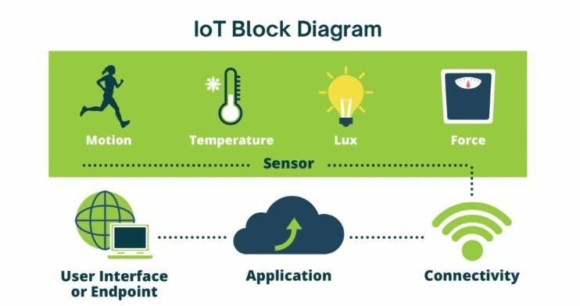

Major Security Challenges in IoT

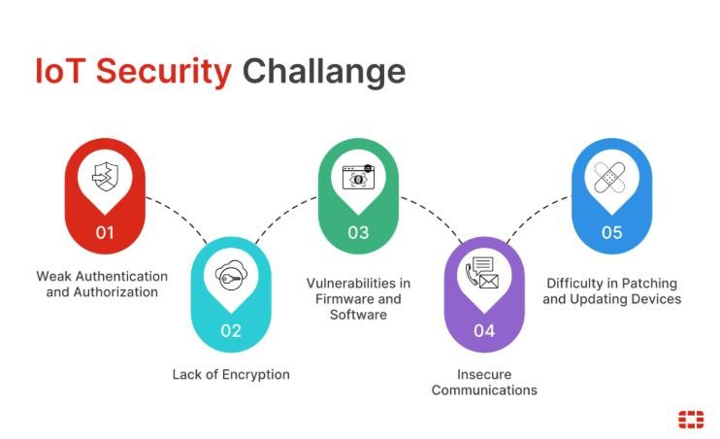

1. Weak Passwords
Many IoT devices use default usernames and passwords which are easy to guess. Users often fail to change these passwords, allowing attackers to gain unauthorized access.

2. Lack of Software Updates
IoT devices may run outdated firmware or software versions. Old software contains vulnerabilities that hackers can exploit.

3. Data Privacy Issues
IoT devices collect large amounts of personal and sensitive data. If this data is not protected properly, attackers may steal or misuse it.

4. Insecure Communication
Some IoT devices transfer data without encryption. Hackers can intercept the communication between devices and networks.
5. Malware and CyberattacksIoT systems can become targets of malware, ransomware, and denial-of-service attacks. Hackers may control multiple IoT devices using botnets.

Smart Home Attack
A smart home system includes cameras, smart locks, and sensors connected to Wi-Fi. Due to weak passwords and no updates, hackers were able to access the network.
Impact:
- Security cameras were hacked
- Smart locks were controlled remotely
- Private data was exposed
- Privacy was violated
- Unauthorized access to smart devices
- Financial loss due to cyber attacks
- Misuse of smart home systems (cameras, locks, etc.)
- Increased risk of hacking in IoT networks
- Loss of user trust in IoT technology

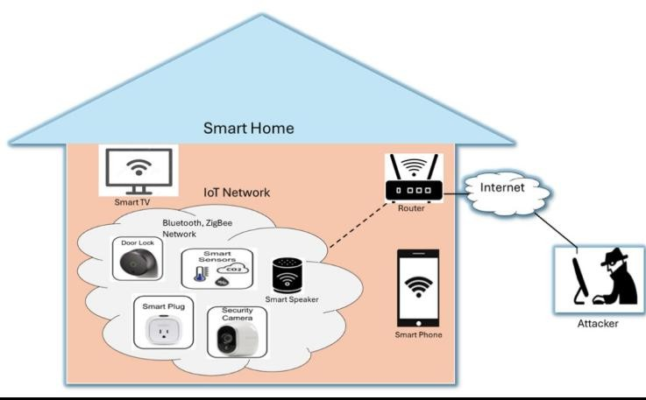

Solutions for IoT Security
To improve IoT security, several important steps should be followed. These steps help protect devices from cyber attacks and ensure safe communication.

Step 1: Strong Passwords
Users should change default passwords and set strong, unique passwords for each IoT device.

Step 2: Data Encryption
All data should be protected using encryption methods like HTTPS, SSL, or TLS.
Step 3: Regular Updates
IoT devices must be updated regularly to fix security vulnerabilities.

Step 4: Secure Network
A secure Wi-Fi network (WPA2/WPA3) should be used, and public WiFi must be avoided.

Step 5: Authentication
Two-Factor Authentication (2FA) should be enabled to add extra security.

Step 6: Firewall Protection
Firewalls should be used to block unauthorized access to the network.

Step 7: Device Monitoring
Connected devices should be checked regularly, and unknown devices must be removed immediately

Advantages of IoT
- Enables automation of daily tasks
- Provides remote monitoring and control
- Improves efficiency and productivity
- Saves time and human effort
- Useful in smart homes, healthcare, and agriculture
- Helps in real-time data collection and analysis
- Improves decision-making using data insights
- Enhances comfort and smart living experience

Disadvantages of IoT
- High security risks and cyber attacks
- Privacy issues due to data collection
- Devices are vulnerable to hacking
- High installation and maintenance cost
- Dependence on internet connectivity
- Complex system management
- Firmware and software vulnerabilities
- Lack of standard security in many devices

Conclusion
The Internet of Things (IoT) is an emerging technology that plays a major role in smart homes, healthcare, agriculture, and industrial applications. It provides automation, remote monitoring, and efficient data management, making daily life easier and more convenient.
However, IoT systems face several security challenges such as weak passwords, lack of encryption, outdated firmware, and unauthorized access. These issues can lead to serious problems like data theft, privacy loss, and device manipulation.
To overcome these challenges, proper security measures such as strong authentication, encryption techniques, regular software updates, and secure network configuration must be implemented. Ensuring IoT security is essential for protecting users, data, and connected systems.

References
- IEEE Internet of Things (IoT) Journals and Research Papers
- Cyber Security and IoT Security Articles from trusted websites
- International Journal of Computer Science and Engineering (IJCSE)
- Official IoT documentation and online learning resources
- NPTEL / Coursera IoT and Cyber Security materials

ACKNOWLEDGEMENT

I would like to thank CodeAlpha Internship Program for giving me this opportunity.
I also thank my college faculty and department for their support.

Thank You

